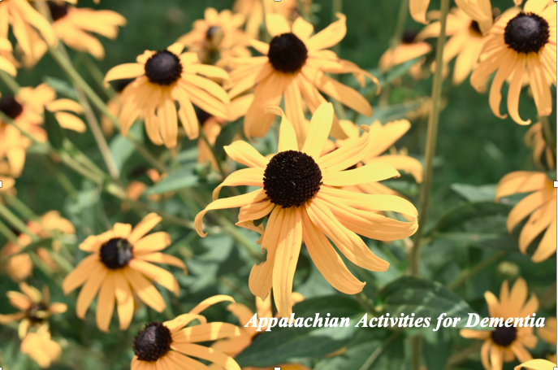

Photo by Alyssa Guerry

West Virginia-Appalachian Activities

Dementia affects many aspects of one’s life, such as memory, behavior, feelings, and even relationships with others (Alzheimer’s Association, 2020). Something that does not change is the desire to feel valued, respected, and be a contributing member to one’s community. One way to improve quality of life, reduce depression, and increase personal competence is to socialize and engage with friends, family, and the community through meaningful experiences. It is often difficult to find activities that are well-suited for those with dementia. This manual was created in order to offer meaningful and enjoyable activities for persons with dementia. These activities involve “reminiscing” or remembering past experiences. In hopes of developing the most meaningful experiences, the activities included in this manual are based on crafts, games, folklore, music, and other aspects of Appalachian culture.
Each activity listed in this manual contains a justification, estimated time it takes to complete the activity, the estimated difficulty of the activity for adults with dementia, and a list of the materials needed in order to complete the activity. The justification gives information about what skills this activity will target for adults. The estimated time it takes to complete the activity includes set up, delivery, and clean up. The estimated difficulty relates to how difficult the activity is for the adult with dementia and the amount of assistance they may need from a friend, caregiver, or activity director. Some of the materials listed for activities will be available online to download or available at the back of this manual, those materials will be designated as such.
The activities in this manual will work best with individuals who grew up or spent many years living in the Appalachian region of the United States (which includes all of West Virginia and parts of Alabama, Georgia, Kentucky, Maryland, Mississippi, New York, North Carolina, Ohio, Pennsylvania, South Carolina, Tennessee, and Virginia). While this manual was created with adults from Appalachia in mind, these activities are meant to be those enjoyed by friends and family as well. They can be used in a group setting in long-term care facilities, and at home with other family members.

If you decide to and use the manual, please consider completing a short satisfaction survey. Feedback gathered from this survey will help us improve the manual.

Thank you for your interest in using the activities in this manual!

Julie Hicks Patrick
Kristina Hash
Michaela Clark
Alexandria Ebert
Amber V. Rusch (supported by NIH #1R25AG059558)
Madeline Marello

West Virginia University
Acknowledgments

We would like to thank the following individuals for reviewing our activities manual:

Marla Berg-Weger
Professor, School of Social Work
Executive Director, Geriatric Education Center
Saint Louis University

Cameron J Camp
Director of Research and Development
Center for Applied Research in Dementia
Solon, OH

Diane Kisinger
Activities Assistant
Sundale Nursing Facility
Morgantown, WV

Jane Marks
Certified Dementia Practitioner and Caregiver Advisor
Sandwich Caring
Charleston, WV

Teresa Morris
WV Program Director
Alzheimer's Association, WV Chapter
Charleston, WV

The team would also like to express our sincerest gratitude to the following organization and individuals for their contributions to this project:

The Center for service and Learning at West Virginia University (Community Engagement Grant)

The Beatrice Ruth Burgess Center for West Virginia Families and Communities, School of Social Work, West Virginia University (Beatrice Ruth Burgess Center and Karen Harper-Dorton Faculty Scholar Grant)

Dr. Cameron Camp, Center for Applied Research in Dementia, Solon, OH

Donna Tennant and Diane Kisinger and the staff and residents of Sundale Rehabilitation and Long-Term Care, Morgantown, WV

The Alzheimer's Association- West Virginia Chapter

Dr. Chris Haddox, Interior Design and Design Studies, West Virginia University, Musical Artist

Dr. Rosemary Hathaway, Department of English, West Virginia University

Lori Hostuttler, West Virginia and Regional History Center, West Virginia University

Resources

Alzheimer’s Association. (2020). 2020 Alzheimer’s disease facts and figures. Alzheimer’s & Dementia.

Goldenseal Magazine
Publication with content related to traditional life in West Virginia, including history, folklore, and music.

West Virginia Department of Arts, Culture, and History
Offers databases and information on events related to WV arts, culture, and history (including genealogy research and other archived information).

West Virginia and Regional History Center (West Virginia University)
Provides access to a variety of photographs, files, and information related to the history of WV and the Central Appalachian Region.

West Virginia and Regional History Center (West Virginia University)
West Virginia History Onview
Online database of over 50,000 historical photos from West Virginia

West Virginia - Appalachian Games

1.1 TIC TAC TOE
Justification: Fine motor skills, Cognitive Exercise, Social interaction.
Estimated time: 5 minutes per game
Estimated difficulty: Easy
Materials: One game of tic tac toe needs a wooden game board and contrasting colored marbles (5 of each, 10 total marbles). Can also be completed with more easily accessed materials: pencil and paper, using contrasting marks instead of marbles (X’s and O’s).
1.2 Build Background
History: Tic tac toe is a common grade-school game, it was traditionally played on a wooden game board with marbles. Other ways this game was traditionally played was using a stick and dirt outside, marking the ground with a grid, X’s and O’s.
Marbles have been used in Appalachian history for many children's games. Glass marbles commonly made by German-immigrants, were cheap and found in the homes of many Appalachian families. Today, there are only two marble manufacturers left in America - one is Marble King, in Paden City, West Virginia.
Enrichments: Add any pictures of this game being played or objects used in the game.
Access to Background Knowledge:
- Did you ever play this game growing up?
- Do you have any good stories about this game?
- Did you win tic tac toe against family or friends?
- What styles of marbles did you play with?
- Did you play tic tac toe with marbles on a wooden game board? Or another way?
Interest Sparker: Consider doing something to spark interest. Showcase marbles of different materials (glass, clay, steel, plastic or agate), and unique marble styles (cat’s eye, crystal or clear, swirly, shooter, etc.).
1.3 Play Tic Tac Toe
Goal of tic tac toe: to be the first player to get three in a row on the 3x3 grid.
- Two players, each have contrasting marble colors (when playing on a wooden board) or each take different letters (Xs or Os on a hand-drawn grid).
- Each player takes a turn placing marbles on the 3x3 grid or drawing their letter on a hand-drawn grid.
- The game is complete once one player gets three in a row (can be horizontal, vertical, or diagonal), or when all squares of the 3x3 grid are filled in, resulting in a tied game.

1.4 Activity Extension
Estimated Time: 5-10 minutes per game
To increase the difficulty of tic tac toe: play on a larger grid of 4x4 needing 4 in a row to win, or 5x5 needing 5 in a row to win.
- 4x4 game board needs 16 marbles of contrasting colors per game
- 5x5 game board needs 26 marbles of contrasting colors per game
2.1 FLIPPERDINGER
Justification: Fine motor skills, Cognitive Exercise, Building stamina.
Estimated time: 5-10 minutes
Estimated difficulty: Medium
Materials: One flipperdinger per player (groups can take turns if resources are limited). Traditionally made out of a hollow reed, wire, and a small ball of corn stock. Instructions to craft a flipperdinger are found in the back of this book.
2.2 Build Background
History: The flipperdinger is an inexpensive children’s toy made from materials often found outdoors. Traditionally, a flipperdinger’s base is made out of a hollow reed, like a river cane, or other materials such as clay or metal tubes. The flipperdinger can have a wire hoop which a ball is blown through, or an acorn cup which catches the blown ball. The ball is traditionally made from cornstalk pith, or other materials such as a cork ball or a dried pea.,
The flipperdinger is a commonly enjoyed toy throughout Appalachia. This hand-made toy had two versions: a flipperdinger with a wire hoop and wire through the ball with a kink on one end, where the goal is to blow the ball and hook it on the hoop, and the flipperdinger with an acorn cup, where the goal is to simply balance the ball while blowing through the tube.
Enrichments: Add any pictures of this game being played. Have a flipperdinger ready to show participants or make a flipperdinger during the activity.
Access to Background Knowledge:
- Did you ever play flipperdinger growing up?
- Do you have any good stories about this game of flipperdinger?
- What kind of flipperdinger did you play with? Hoop or cup?
- Did you play with any friends or siblings? Any other important people in your life?
Interest Sparker: Consider showing the two different types of flipperdingers (hoop and cup). You may also display flipperdingers made of different types of materials. If using the hoop flipperdinger, possibly make it a friendly competition of who can hook the ball on the hoop fastest. If using the cup flipperdinger, have a competition of who can balance the ball the longest.
2.3 Play Flipperdinger
Hoop Type: Goal of the game is to hook the ball to the hoop.
- Position the ball with its wire kink underneath the metal hoop, placing ball in the top facing hole under the hoop
- Blow through the side facing hole, using air to move the ball upwards
- Try to blow the ball with its wire kink to hook on to the metal hoop

Cup Type: Goal of the game is to balance the ball in the air.
- Position the ball over the top facing hole in the cup
- Blow through the side facing hole, using air to move the ball upwards
- Try to blow the ball in a straight line, keeping the ball in the air

3.1 MARBLES GAME
Justification: Fine motor skills, Cognitive Exercise, Social interaction, Building stamina, Increases community.
Estimated time: 20 minutes, depends on group size
Estimated difficulty: Medium
Materials: Each group of 2 - 6 players needs a smooth surface to play on and mark a circle (either string and tape when inside, or chalk when playing outside). 13 standard sized marbles and one larger “shooter” marble per player, which is no greater than three quarters of an inch in diameter. String should be about 9.5 feet long, to be able to make a circle at least 3 feet in diameter. The larger the circle, the harder the game - usually up to 6 feet in diameter. Be sure that participants identify the items as marbles, as they could be misidentified as hard candy for those in later stages of dementia. Participants must also be able to engage fine motor skills to play this game.
3.2 Build Background
History: Marbles are a traditional children's pastime, and there are many different types of games children have used these small glass balls to entertain themselves with. There are unique names given to each marble type: “commie” - a handmade clay marble, “milkie” - a translucent white marble, “aggies” - often made from agate a colored quartz gemstone, “clearies” - often translucent clear glass, and “steelies” - are like ball bearings.
Marbles have been used in Appalachian history for many children's games. Glass marbles commonly made by German-immigrants, were cheap and found in the homes of many Appalachian families. Today, there are only two marble manufacturers left in America - one is Marble King, in Paden City, West Virginia.
Enrichments: Add any pictures or videos of this game being played or objects used in the game, any music or sounds associated with this game. Or is there even a food or snack that goes well together. List the five senses, how can we give more context to this craft. A post-activity discussion could include questions like “has anyone been to the WV marble factory, did your children play with marbles? your grandchildren?; does anyone still have marbles that you can bring to the group?; and what memories did playing marbles bring back for you?”
Access to Background Knowledge:
- Did you ever play this game growing up?
- Do you have any good stories about this game?
- Did you win marbles against family or friends?
- What styles of marbles did you play with?
- Did you play with marbles in the dirt? Or another way?
Interest Sparker: Consider doing something to spark interest. Showcase marbles of different materials (glass, clay, steel, plastic or agate), and unique marble styles (cat’s eye, crystal or clearie, swirly, shooter, etc.).
3.3 Play
Part one: Set up the game.
- Draw the circle with chalk or make the circle with string. Circles can be from 3 feet to 6 feet in diameter, the larger the circle the harder the game.
- Mark two lines on either side of the circle, this can be done with chalk or tape.
- To determine who goes first, players stay behind one line and shoot a marble towards the other line. Whoever has the closest marble to the line goes first, the next closest then goes next, and so on. The game can be played with teams or as every person for themselves.
- Set up the 13 standard marbles inside of the circle, this can be done in a cross shape, a circle shape, or randomly drop marbles in the center.
A. B. C.

Part two: Play marbles.
- The first player sitting outside of the circle holds their larger shooter marble in one hand with at least one knuckle touching the ground. With their thumb they flick the marble into the circle.
- The goal of each turn is to knock one or more marbles outside of the circle while leaving the shooter inside, these count as points. If the shooter stays inside, then the player can go again. If the shooter goes outside, then it is the next person’s turn to shoot.
- Players can knock out other players shooter marbles, this puts the other player at a disadvantage as they must shoot then outside of the circle which is farther away from the marbles.
- The game ends when all the marbles are knocked out of the circle, whoever has the most points/marbles wins.

West Virginia Crafts

1.1 CORN HUSK DOLLS
Justification: Fine motor skills, Gross motor skills, Building stamina.
Estimated time: 20 minutes
Estimated difficulty: Medium-Difficult
Materials per person: Corn husks soaked in water for 10-15 minutes, some string, any materials you want for decorating (e.g., pens, markers, etc.)
1.2 Build Background
History: Explain when and where this craft was popular. What is a common way to use this craft. Explain some possible slight variations of this craft.
Enrichments: Add any pictures of this craft, any music or sounds associated with this craft. Or is there even a food or snack that goes well together. List the five senses, how can we give more context to this craft.
Directions: Soak corn husks in water for 10-15 minutes in order to make them soft and pliable.

- Layer 4 corn husks and tie a string around the narrow end of the 4 husks. String should be about 1 inch from the end of the husks.
- Fold the husks down over top of the string you tied. Two husks on each side of the 1- inch section.
- Tie a string around the husks in order to form a head.
- Roll up another husk into a tight tube to use for arms. Tie a string on each end.
- Place arms between the husks (sandwich them between the two middle cornhusks).
- Tie a string around the four cornhusks in order for create a “waist.”
- Trim the excess on the bottom in order to create a skirt.

Access to Background Knowledge:
- Did you grow up making corn husk dolls?
- What kinds of crafts did you enjoy growing up?
- Do you have any fond memories of crafting with family or friends?
- Do you have any good stories about this craft?

Interest Sparker: Consider, doing something to spark participants interest. Like for quilting, consider showing multiple styles of quilt patterns or discussing importance of color.

West Virginia Music

Explain how the following section works. Use bold when referring to a section. Explain that the follow up section is to be used after each craft or crafting session.

1.1 Fun with Music- A matching activity
Justification: Gross motor skills, Cognitive Exercise, Auditory processing, Building stamina, Social interaction, Verbal expression/communication, Increases community.
Estimated time: 15 minutes
Estimated difficulty: Easy- Medium
Materials per person: To play the matching game, use the sheets with musicians and corresponding names at the back of this manual.
1.2 Build Background
History: Explain when and where this music was most popular. Discuss some of the instruments and people known with this type of music. All of the musicians in this manual are from the Appalachian region.
Enrichments: Show adults photos the instruments, musicians, or bands. Photos of album covers can be used, too, in order to spark interest or memory. This may be used in conjunction with festivals if older adults are able. Actual musical instruments could also be presented or music could be performed live by local musicians or even the participants or family members.

Directions: Cut along the dotted line and separate the photographs from the names. Line up the names on a table and show participants the photos one by one. Have them pick the correct name from the table.
Access to Background Knowledge:
❏ Make a few general starting questions for the artists and/or type of music?
❏ Did you ever play this music on the radio/records?
❏ Do you have any good stories about Appalachian music?
❏ Did you ever hear this before?
❏ Do you have fond memories of this music/artist?

1.3 Other Activities
Part one: Musicians
1) Go over mini biography to spark interest
2) Photos of musician/group
3) Introduce album covers?
Part two: Listening to Music
1) Top 3-5 songs by musician
2) Listen to the music
3) Participate through singing/ simple instruments?
Part three: Music out in the community
1) Bring music to the older adult (guitar?)
2) Take out into the community (festivals?)

Resources: See appendix for materials including pictures, descriptions, etc.

West Virginia – Foods

1.1 Matching
Justification: Fine Motor Skills, Cognitive Exercise, Social interaction.
Estimated time: 5-10 minutes per game
Estimated difficulty: Easy-Medium
Materials: Use the food cards at the back of this book to complete a matching game. Cut along the dotted line to separate the name from the photo. Mix the photos and name cards up and arrange them in rows. Present one picture card at a time and have the participant match it to the correct label.
1.2 Build Background
History: All of the foods included are common among the Appalachian region. They are foods that one would have likely been exposed to growing up in West Virginia or the Appalachian region.
Enrichments: Can engage sense of smell by cooking or cutting up foods.

Access to Background Knowledge:
- Did you ever eat any of the foods growing up?
- Do you have any fond memories of cooking with family or friends?
- What were your favorite foods growing up?
- Any foods that you did not like?

West Virginia – Famous People BINGO

1.1 BINGO-Famous West Virginians
Justification: Fine Motor Skills, Cognitive Exercise, Social interaction.
Estimated time: 10-15 minutes per game
Estimated difficulty: Easy-Medium
Materials: Use the cards at the back of this manual to guide individuals or groups in a game of BINGO. Hold up the side of the card that has a blank and half of the famous person’s name (e.g., Dolly_________). The back of the card will have the answer and some information regarding that individual to help create ideas for further conversation. This side of the card is for the BINGO caller to use only. The BINGO caller will read off the card (e.g., “Dolly blank”) and then participants will search their card to see if they have the answer (Parton) on their card. Participants will also need the BINGO cards with famous Appalachian people listed on them and BINGO chips or coins to mark your cards with answers.
1.2 Build Background
History: All individuals on the famous persons BINGO sheets are famous people from West Virginia specifically. Many older adults will have heard of some of these famous individuals throughout their time spent in the Appalachian region.
Directions:
Preparing for the Activity
- You will need all the materials listed above before starting the activity.
- You will also need someone responsible for holding the Bingo answer sheet (the answer keeper). This person will reveal the name and information about each person.
- The person in charge of the answer sheets will also be responsible for folding the answer card. This person will fold the paper in half so the name of the famous person is on the front, and the photo and information is on the back.

Participating in the Activity
- The individual responsible for holding the answer sheets will begin the game. This individual will call out the name on the front of the card, for example: “Don ”. Do not fill-in-the-blank for the players. The answer keeper will have only the name of the famous person showing at this time. The photo and information will be facing the answer keeper.
- The players will try to guess the name that goes in the blank space.
- After each player makes his/her guess, the individual holding the answer sheet will reveal the correct answer by turning the paper to the other side. The second side will have a photo and information about the famous person. The answer keeper will read the information section about the person. This allows room for discussion between the answer keeper and players.
- After the full name of the Famous Appalachian has been identified, and if a Bingo player has that name on his/her Bingo card, the player will put a coin or a Bingo chip over that name.
The first 4 steps will continue for each Famous Appalachian until someone gets four chips/coins in a row- Bingo!

Enrichments: Add a post-game discussion about the individuals who were in the bingo game. Can ask the questions, “
Did you ever see/meet the person, and if so, what do you think this person was like?; Were you a fan of the person?

Access to Background Knowledge:
- Did you ever play this game growing up?
- Do you have any good stories about BINGO?
- Did you ever win BINGO playing with family or friends?
Interest Sparker: Use the information provided on the information sheets (used by the BINGO caller) to ask questions and start a conversation with the participant(s). Add in some of your own favorites by cutting out photos of favorite musicians or famous individuals to use.

West Virginia – Foods BINGO

1.1 BINGO- Appalachian Foods
Justification: Fine motor skills, Cognitive Exercise, Social interaction.
Estimated time: 10-15 minutes per game
Estimated difficulty: Easy-Medium
Materials: Much like the Famous West Virginians BINGO, Appalachian Foods BINGO will use the same materials. Participants will need the Appalachian Foods BINGO
1.2 Build Background (Similar to marbles game, page X)
History: The foods used for this matching game are popular in the Appalachian region. This is the same foods list that is included in the Appalachian foods matching activity.
Directions:
Preparing for the Activity
- You will need all the materials listed above before starting the activity.
- You will also need someone responsible for holding the Bingo answer sheet (the answer keeper). This person will reveal the name and information about each food.
- The person in charge of the answer sheets will also be responsible for folding the answer card. This person will fold the paper in half so the name of the food is on the front, and the photo and information is on the back.

Participating in the Activity
- The individual responsible for holding the answer sheets will begin the game. This individual will call out the name on the front of the card, for example: “Pinto Beans and ________.” Do not fill-in-the-blank for the players. The answer keeper will have only the name of the famous person showing at this time. The photo and information will be facing the answer keeper.
- The players will try to guess the name that goes in the blank space.
- After the players makes his/her guess, the individual holding the answer sheet will reveal the correct answer by turning the paper to the other side. The second side will have a photo and information about the food. The answer keeper will read the information section about the food. This allows room for discussion between the answer keeper and players.
- After the full name of the Appalachian Food has been identified, and if a Bingo player has that name on his/her Bingo card, the player will put a coin or a Bingo chip over that name.
The first 4 steps will continue for each Appalachian Food until someone gets four chips/coins in a row- Bingo!
Access to Background Knowledge:
- Did you ever play BINGO as a child?
- Do you have any good stories about this game?
- Do you enjoy BINGO?
Interest Sparker: A BINGO game might be created with your own favorite foods.

West Virginia – Sounds of Appalachia

1.1 Sounds
Justification: Cognitive Exercise, Social interaction, reminiscence.
Estimated time: 10+ minutes
Estimated difficulty: Easy
Materials: List of sounds familiar to those in Appalachia.
1.2 Build Background
History: The sounds included in this list would some of those that are familiar for those who grew up in the Appalachian region. Sounds that are familiar encourage reminiscence and social interaction among older adults.
Enrichments: Add any pictures to go with these sounds. This might help with sparking interest.
Access to Background Knowledge:
- Are any of these sounds familiar to you?
- What sounds remind you of friends, family, or back home?
- What is your favorite sound from your childhood?

CRICKETS

Cricket sounds

CICADA

Cicada sounds

DEER

“startled call from adult deer”

TRAIN

train horn/passing from left to right

arriving and departing in different platforms

NATURE

night sounds

moderate winds blowing through trees

BIRDS

chickadee

warblers

great horned owl

mourning doves

WATERFALLS

large waterfall

small waterfall

STREAM

Flowing water

woodland stream with birds

Cut along dotted line
Hazel Dickens

The Carter Family
Cut along dotted line
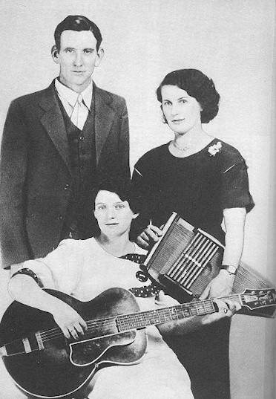

The Carter Family

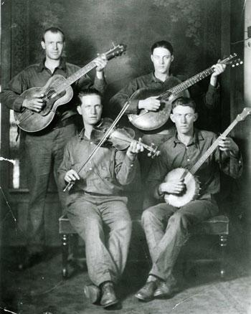
Cut along dotted line
The West Virginia Coon Hunters

Cut along dotted line

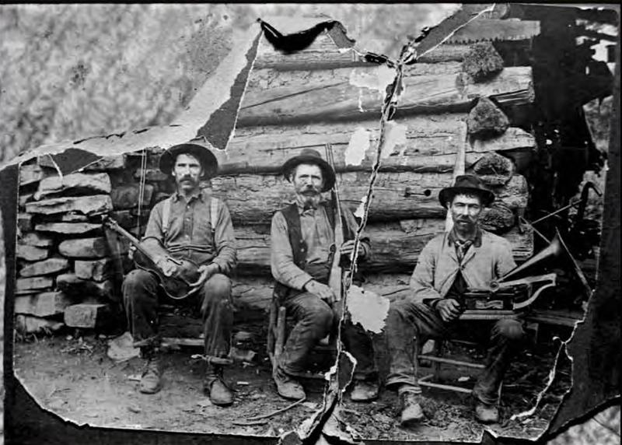

The Hammons Family

Cut along dotted line

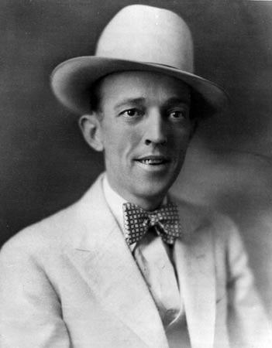

Jimmie Rodgers

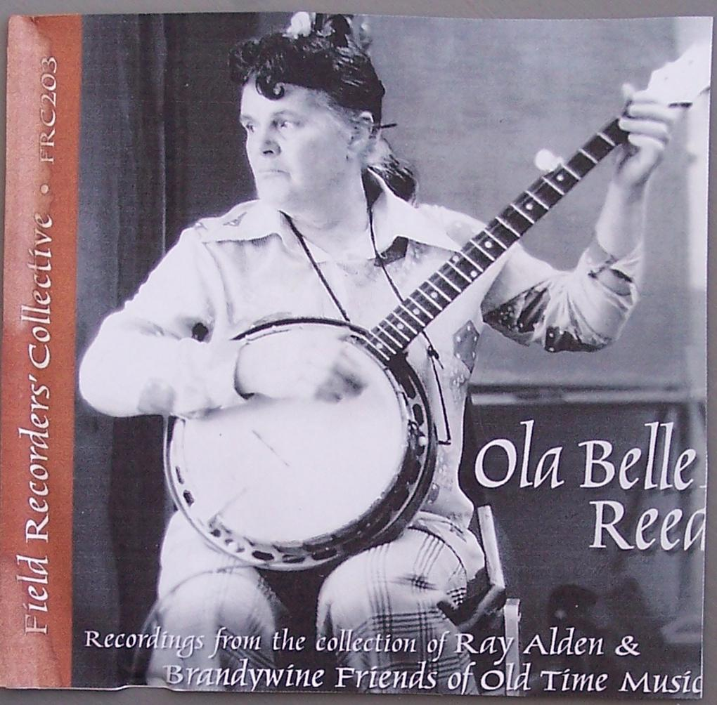
Cut along dotted line

Ola Belle Reed

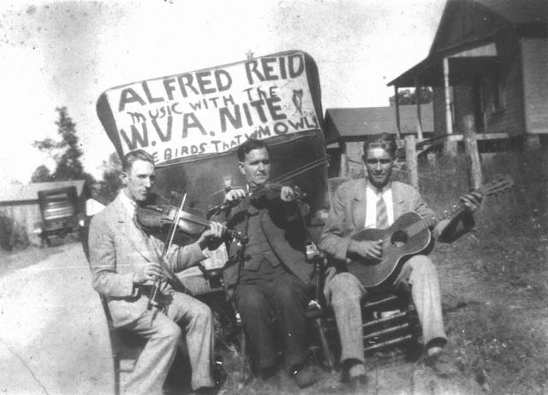
Cut along dotted line

Alfred Reed

Cut along dotted line

Doc Watson

Cut along dotted line

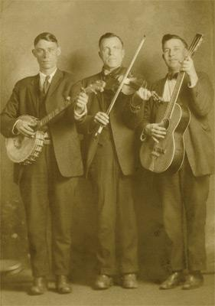

Charlie Poole & the North Carolina Ramblers

Cut along dotted line

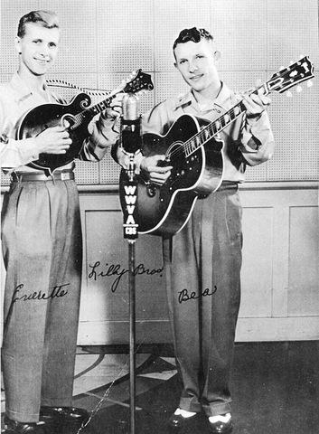

The Lilly Brothers

Cut along dotted line

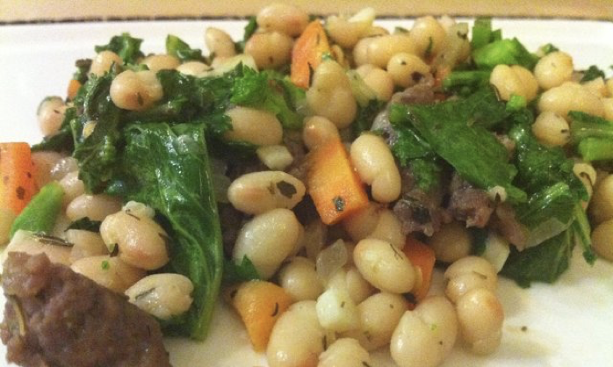

Navy Beans

Cut along dotted line

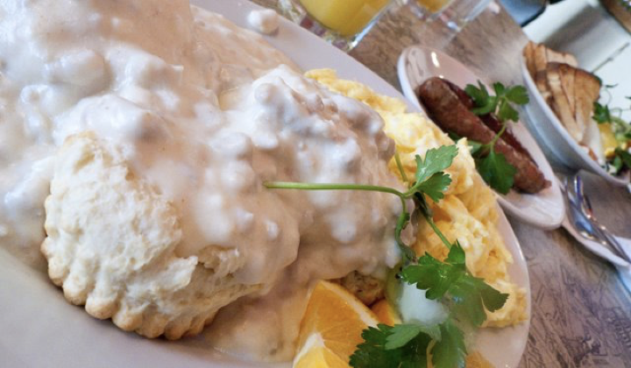

Biscuits and Gravy

Cut along dotted line

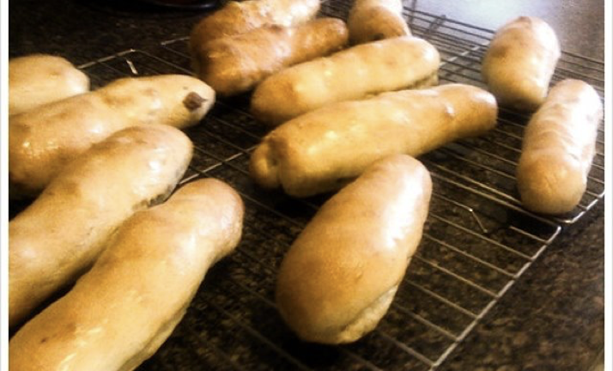

Pepperoni Rolls

Cut along dotted line

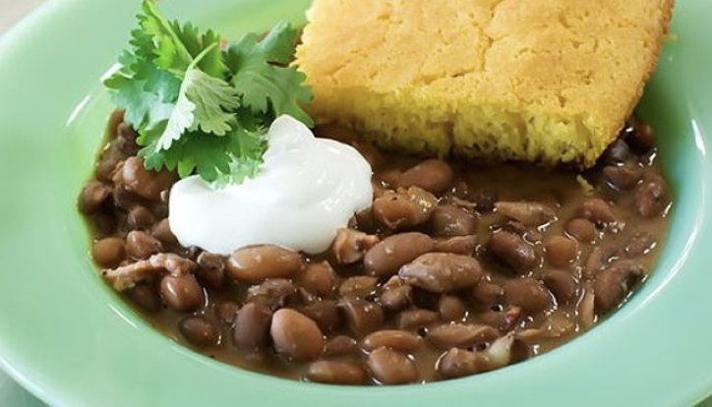

Cornbread and Pinto Beans

Cut along dotted line

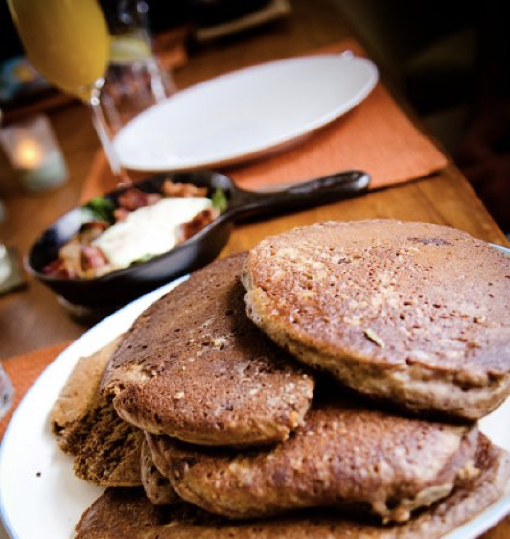

Buckwheat Pancakes

Cut along dotted line

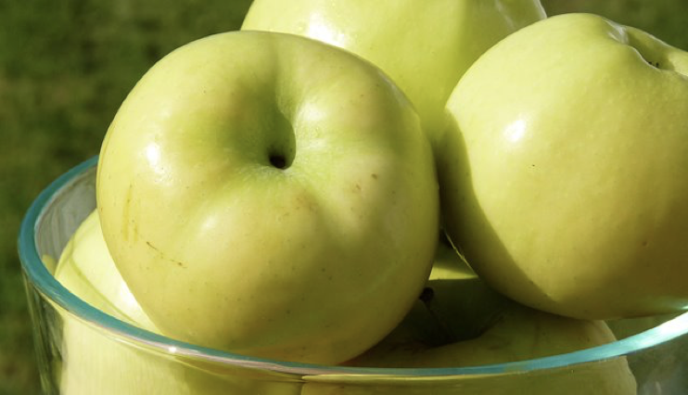

Golden Delicious Apples

Cut along dotted line

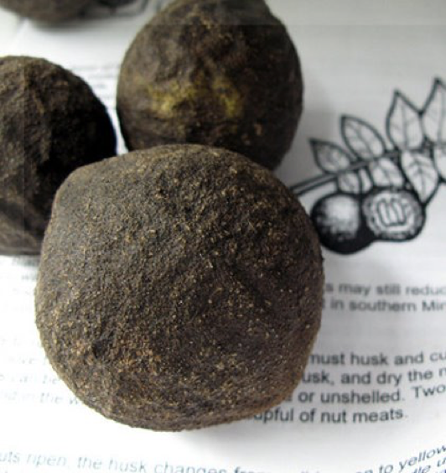

Black Walnuts

Cut along dotted line

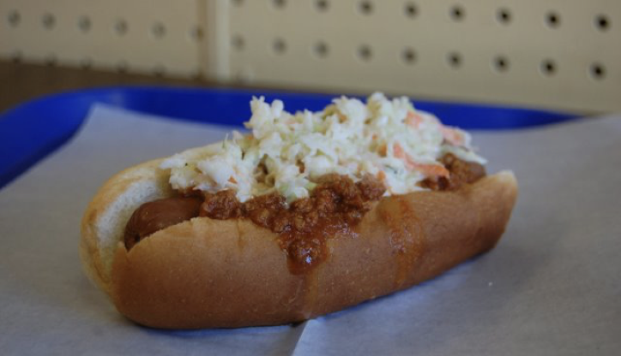

Chili/Slaw Hotdog

Morel Mushrooms
Cut along dotted line

Ramps

Cut along dotted line
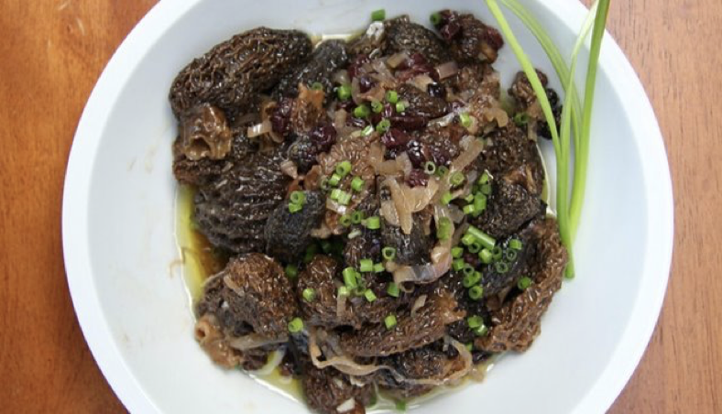
Morel Mushrooms

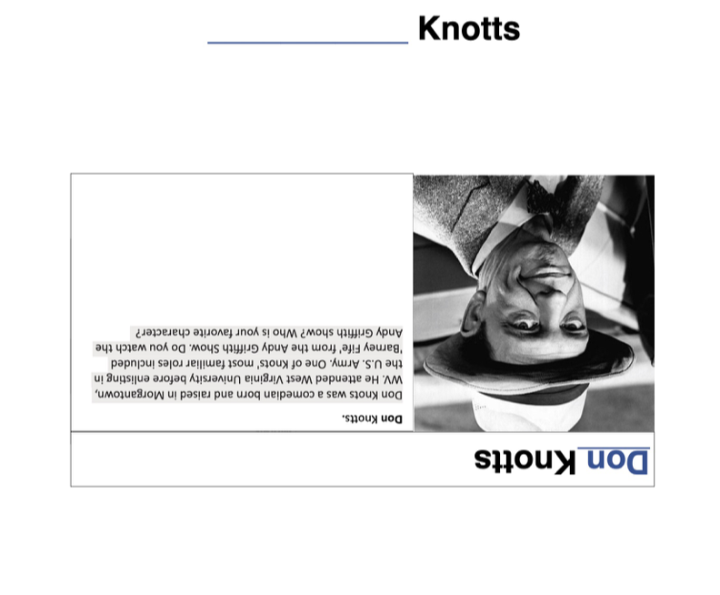
Don _________
Don Knotts
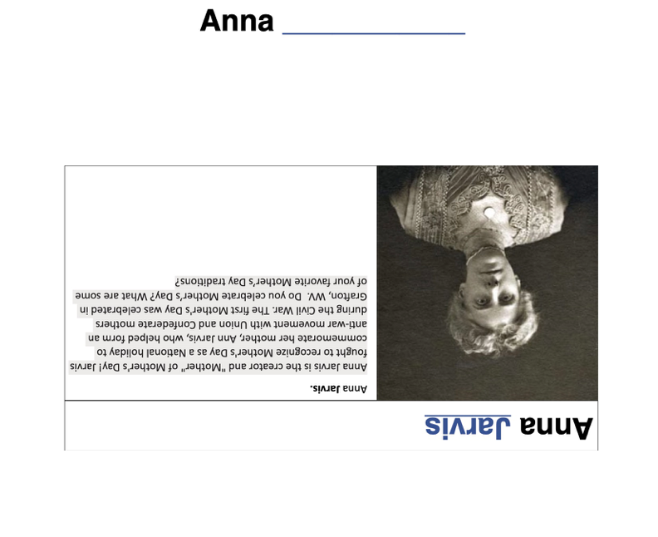
Anna _________
Anna Jarvis
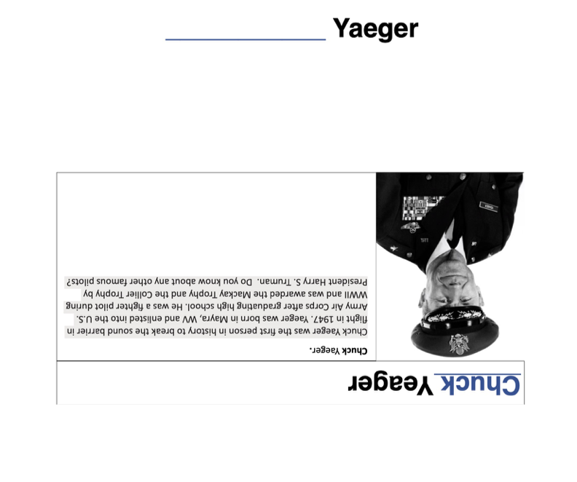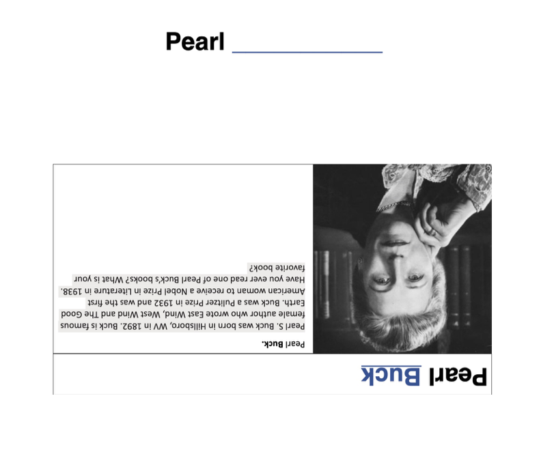
Chuck _________
Chuck Yeager
Pearl _________
Pearl Buck
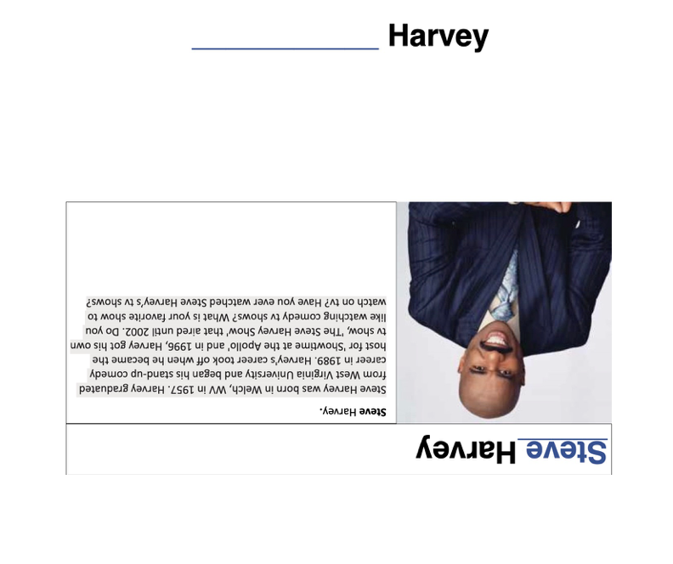
Steve _________
Steve Harvey
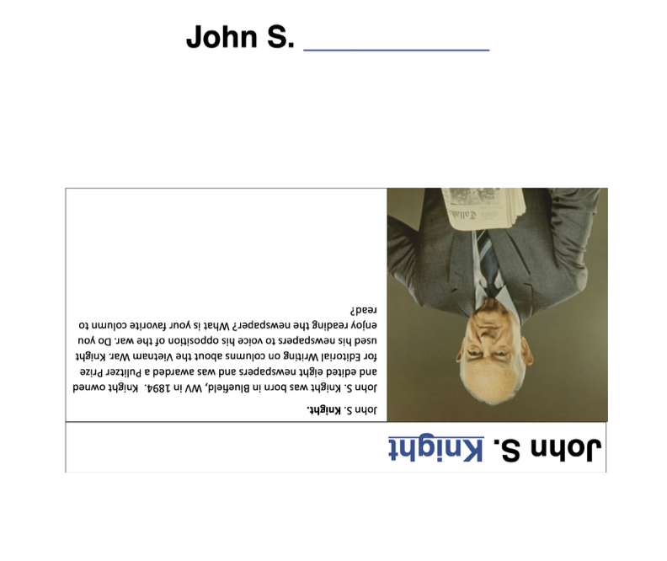
John S. _________
John S. Knight
Peter _________
Peter Marshall
George _________
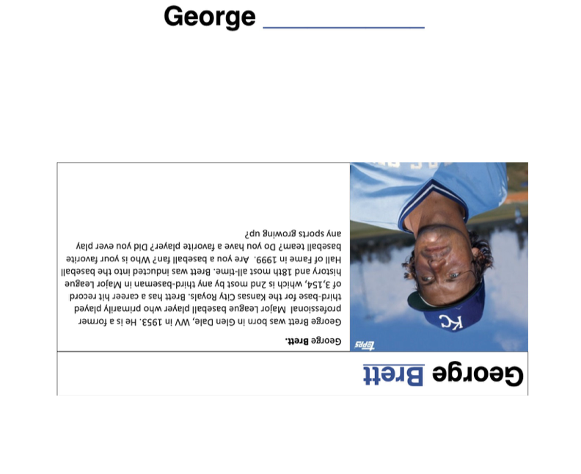
George Brett
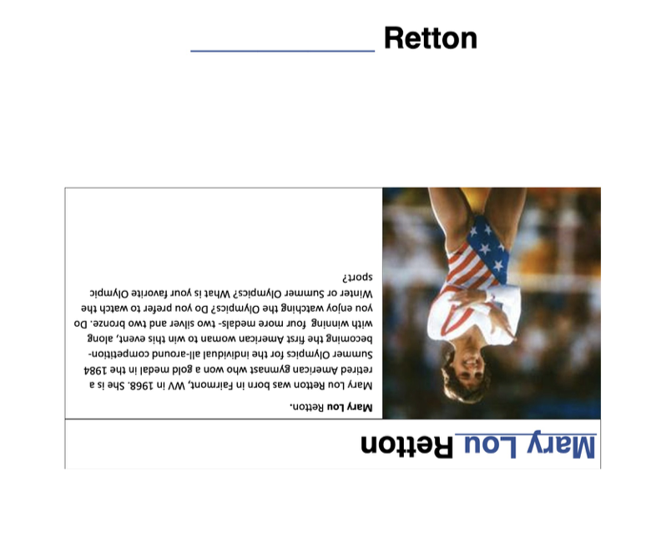
Mary Lou _________
Mary Lou Retton
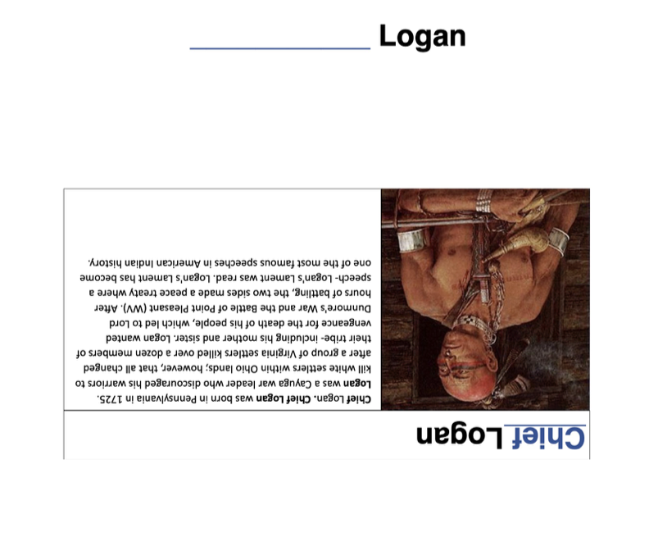
Chief _________
Chief Logan
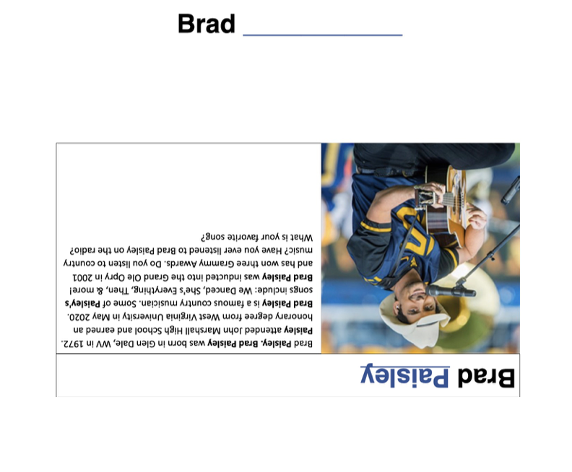
Brad _________
Brad Paisley
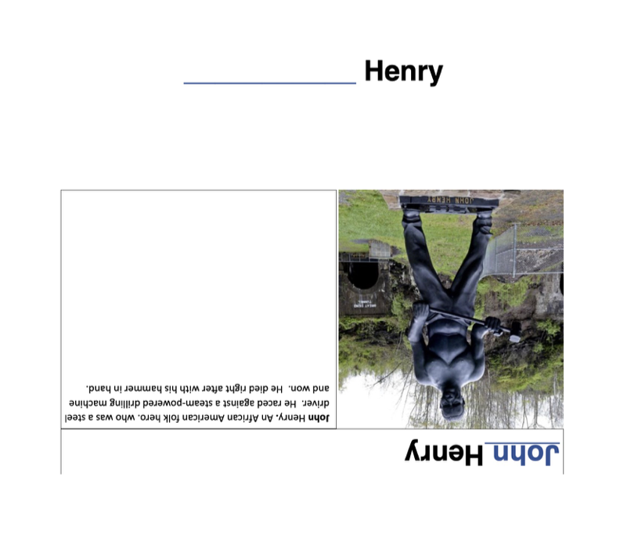
John _________
John Henry
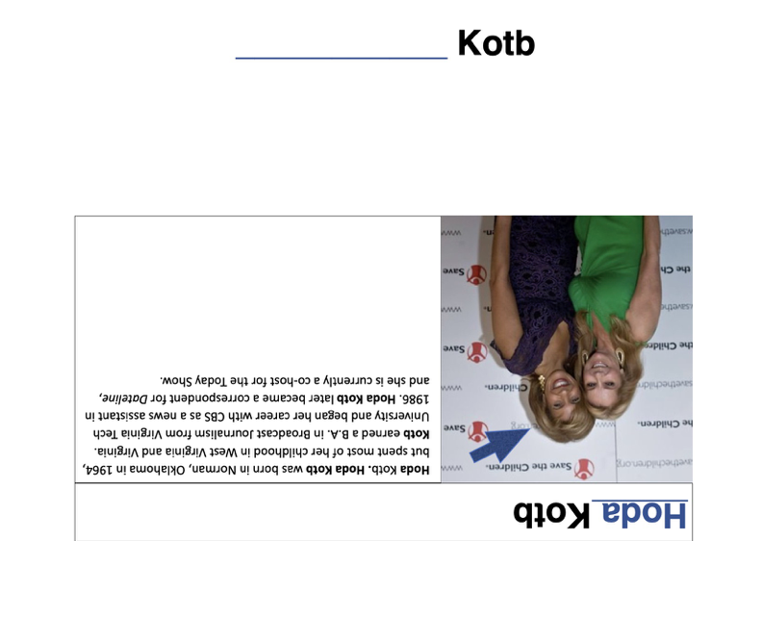
Hoda _________
Hoda Kotb
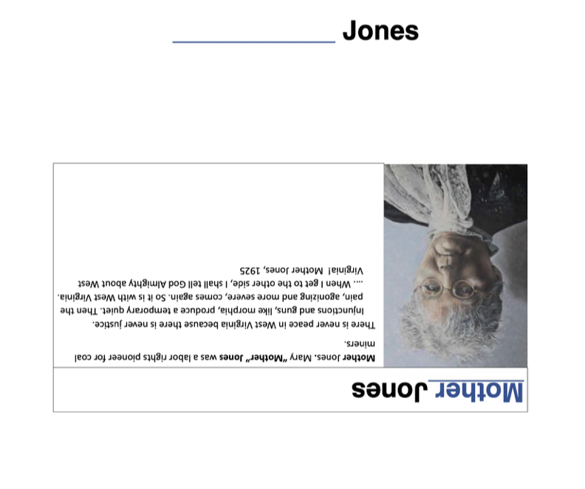
Mother _________
Mother Jones
Katherine _________
Katherine Johnson

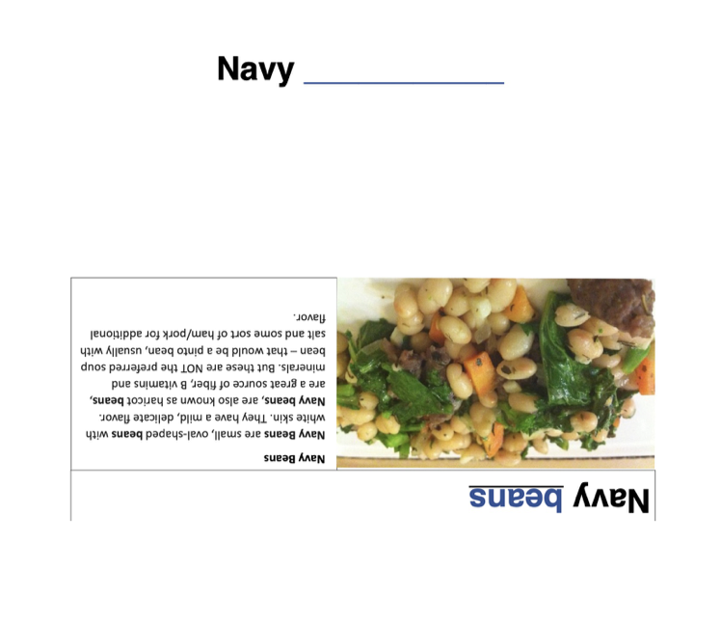
Navy _________
Navy Beans
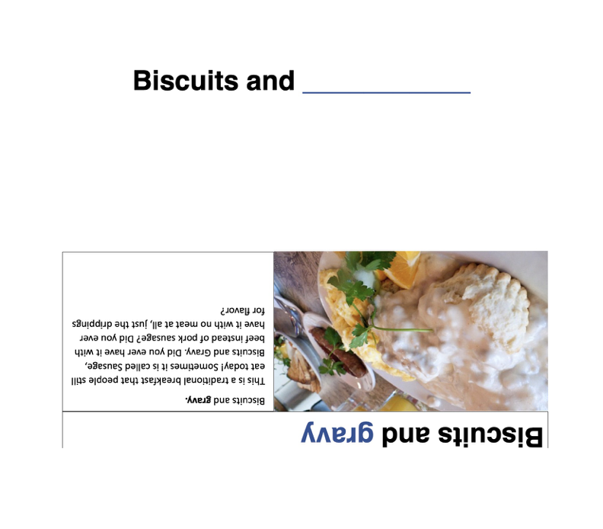
Biscuits and _________
Biscuits and Gravy
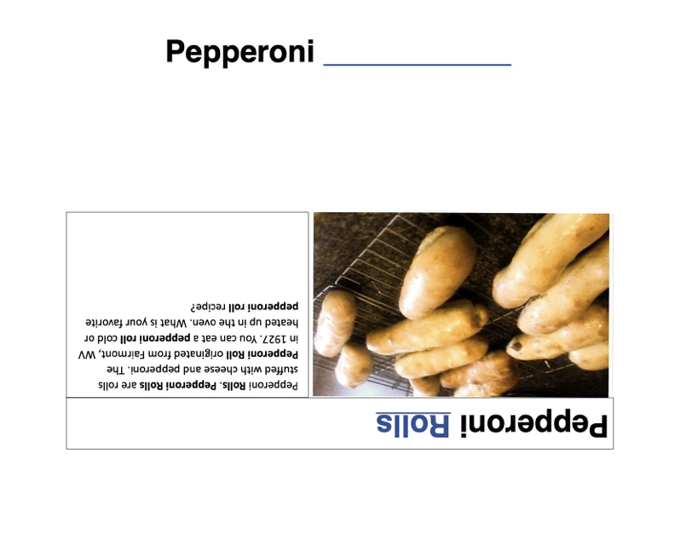
Pepperoni _________
Pepperoni Rolls
Cornbread and _________
Cornbread and Pinto Beans
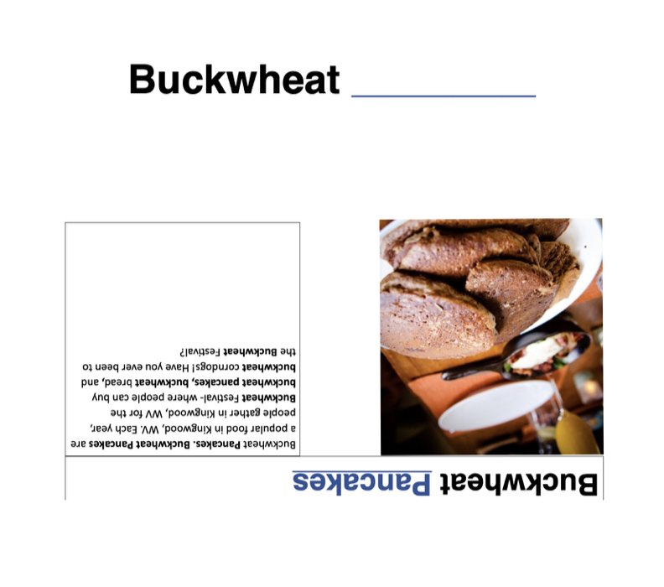
Buckwheat _________
Buckwheat Pancakes
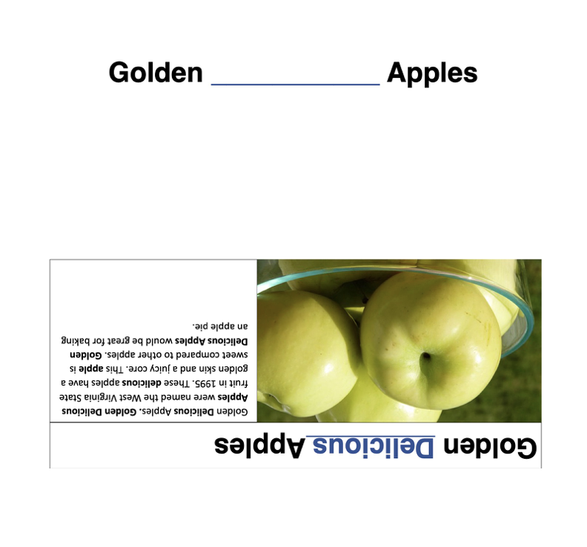
Golden Delicious _________
Golden Delicious Apples
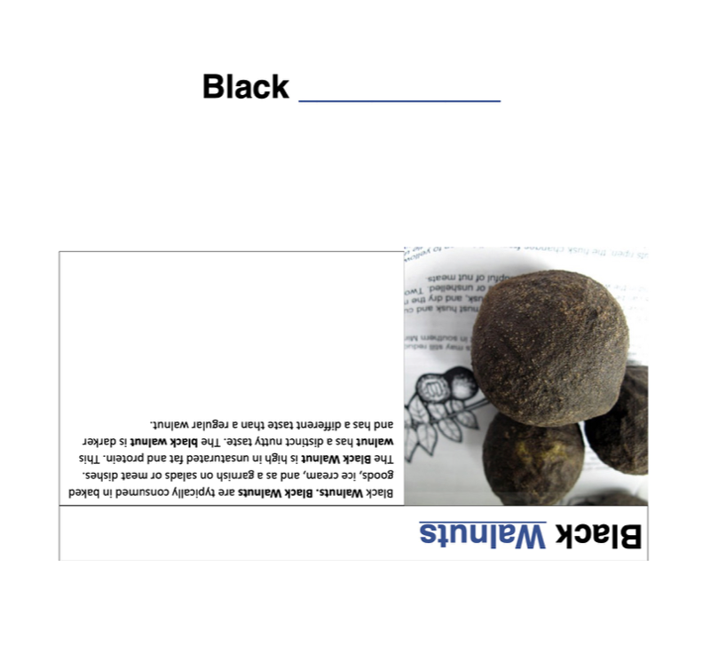
Black _________
Black Walnuts
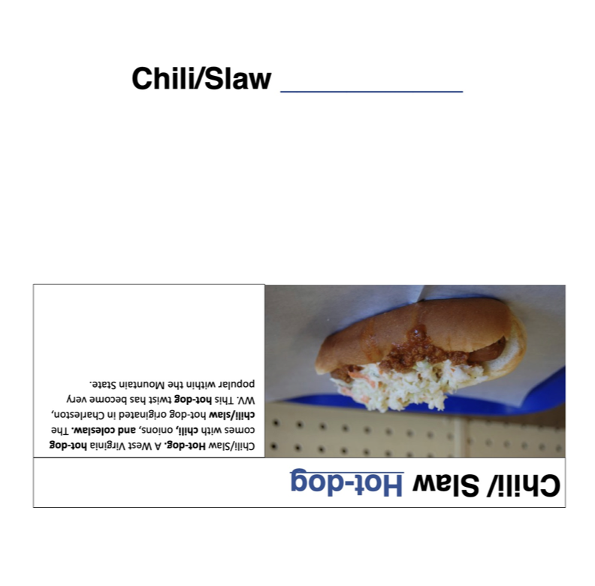
Chili/Slaw _________
Chili/Slaw Hotdog
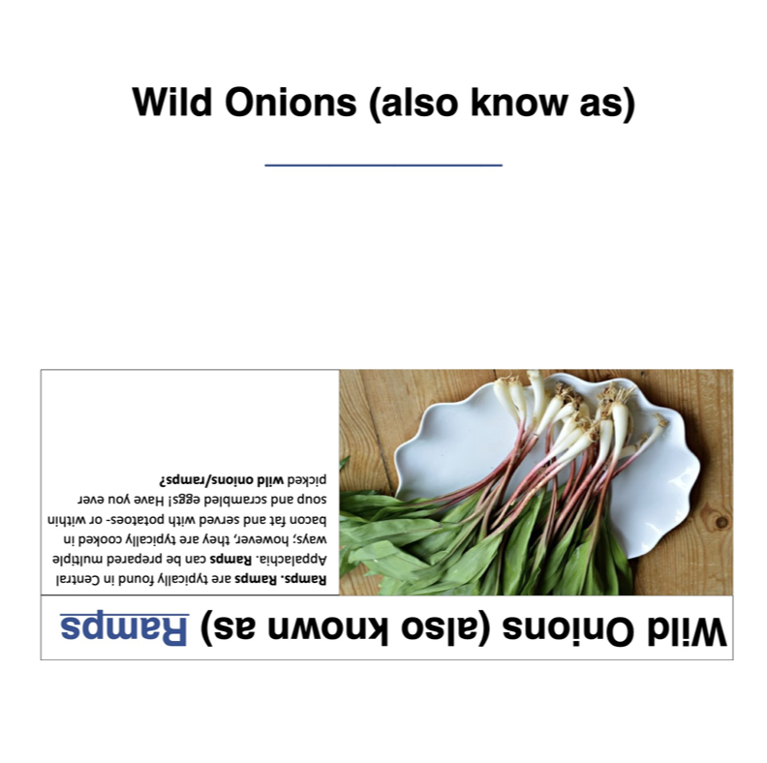
Wild Onions (also known as)
_________
Wild Onions (also known as) Ramps
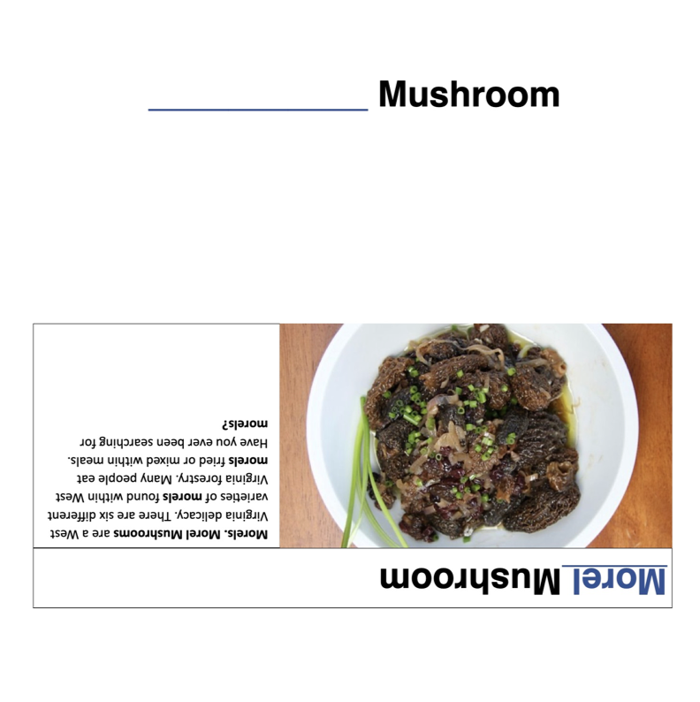
Morel _________
Morel Mushroom

Appalachian Magazine, July 2019
Appalachian history: Stories, quotes, and antecedents, November 2015
Faire Tyme Toys: Flipperdinger
David Wilkison, June 1991
Appalachian Magazine, July 2019
Rules adapted from: How to Play Marbles Video: Howcast, (Sept. 2008). “How to Play Marbles”.

